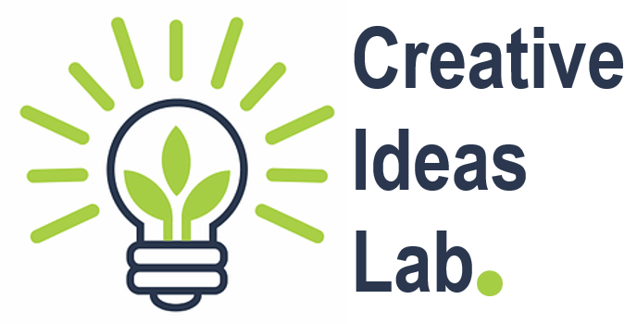
Creative Ideas Lab East Cambridgeshire
Supporting socially-engaged artists to build and test their creative ideas in East Cambs.
We’re offering nine micro commissions for creative practitioners of any artform, to provide a gentle springboard for them to work up a new or existing early idea, that is about connecting people with the arts in some way.
This opportunity is aimed at creative practitioners who have some experience in delivering socially engaged arts activities or projects that make connections with people.
What we have to offer
- A micro commission payment of £200 for each of the nine creative practitioners that are selected from their expression of interest.
- The chance to discuss your idea with a panel of creatives and project managers to get feedback, make connections and gain suggestions for next steps.
- The opportunity to have your idea selected for a £2000 commission to develop and bring to life your project, so that it can be tested/delivered to an identified audience, group or community based in East Cambridgeshire. We have one £2000 commission available.
- The opportunity to have two, one-to-one coaching sessions with a qualified careers coach
All you need to do:
To get started, creative practitioners need to submit an expression of interest either by completing this short online form, or sending in a video of no more than 2 minutes, covering the following points:
- Your name
- Two or three sentences describing your experience in delivering socially engaged arts activities or projects
- A brief outline of your idea - this might be something like “As a filmmaker, I’ve been thinking about how we use our smartphones to capture and edit films and I have the spark of an idea about how to use this technology to create a film with young carers or young people excluded from school...”
- You might show us an example of your work or provide a visual reference point for your initial idea.
If you email us a film we’ll need you to provide your postcode and contact telephone number in the email too.
What we’ll be considering when selecting the nine creative practitioners
- Does the spark of an idea inspire excitement or curiosity?
- Does the creative practitioner demonstrate some experience in working in a socially engaged way?
- Has the creative practitioner thought about who might engage with their idea (the audience/ participants)?
- Could the project help connect with under-represented groups in East Cambridgeshire such as: migrant communities; D/deaf, disabled, neurodivergent people; rurally isolated communities or young carers?
- How diverse is the group of practitioners we’ll be working with and as a group do they represent the community in which we’re based?
More info about how the Creative Ideas Lab works
We’ll look at all the expressions of interest and invite nine people to take part in the Ideas Lab. We’ll send them a simple Letter of Agreement explaining that the commission is to provide them with a little breathing space to develop a creative idea and to attend a group discussion. We’d then pay each person £200.
Between 7th and 11th June, we’ll host some group discussions. Each of the nine creative practitioners would attend one of these sessions.
We’ll select one idea to build into a small project with support from our team. This small project would need to be delivered with a specified audience, group or community in East Cambridgeshire between July and October 2021. The artist will receive a £2000 commission fee to include their time and materials to test/deliver the project.
The eight creative practitioners who are not selected will be provided with two coaching sessions with a qualified coach, for them to use in a way to suit their own plans and goals. If in future we were able to come back to their project idea, we’d get in touch to discuss it further. We might also be able to sign-post creative practitioners to others who could help develop their idea if it’s not quite right for us at this time.
Criteria for expressing an interest:
- Be aged 18 or over and have the legal right to work in the UK
- Have a creative socially engaged arts practice that involves other people e.g. already have experience in creating and/or delivering art and arts opportunities with others (these could be other artists, children in or out of schools, community groups including wider public etc)
- Live in East Cambridgeshire OR
- Live within the Cambridgeshire and Peterborough Combined Authority area and have demonstrable experience of delivering at least one arts opportunity in the last 3 years in the District of East Cambridgeshire.
Express your interest:
Complete our Google Form (link). You can also use the form on the overleaf or, submit a 2 min film to: office@babylonarts.org.uk. If submitting a film please provide a web-link or use a large-file transfer app like WeTransfer. Deadline is 10am on Monday 26th April 2021
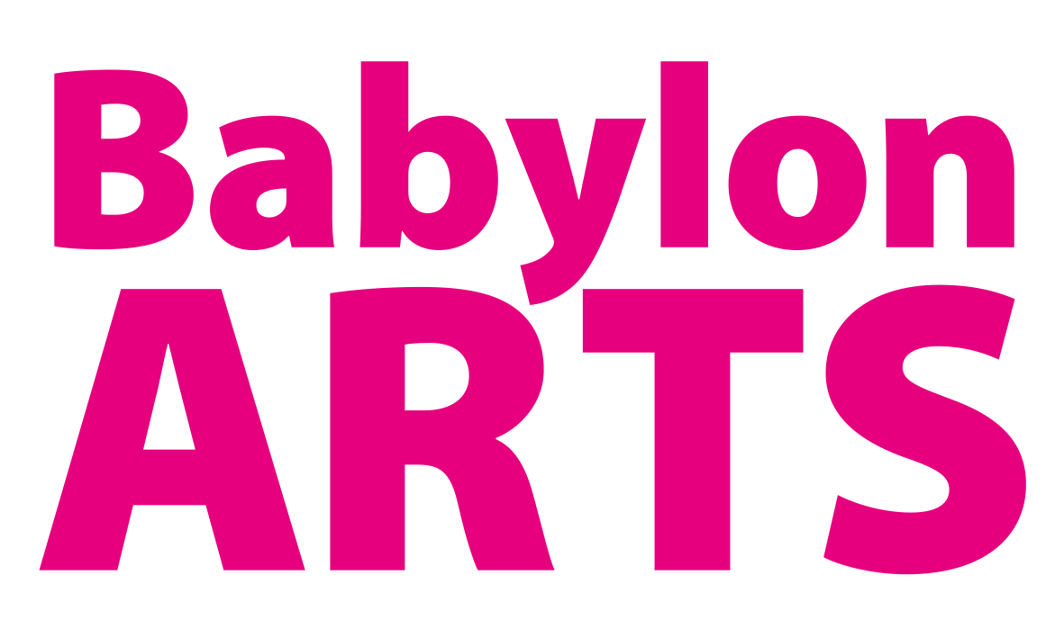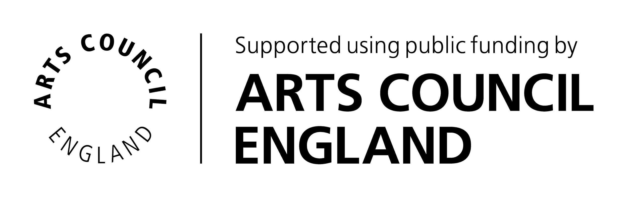This project is funded by the DCMS Culture Recovery Fund (round one).
Artist Ideas Lab - Expression of Interest Form

Thank you for your interest in the Artist Ideas Lab East Cambs.

This is our Expression of Interest Form. In order to be eligible, you need to confirm that you meet the following criteria:
- Be aged 18 or over and have the legal right to work in the UK
- Have a socially engaged creative practice that involves other people e.g. already have experience in creating and/or delivering art and arts opportunities with others (these could be other artists, children in or out of schools, community groups including wider public etc)
- Live in East Cambridgeshire OR
- Live within the Cambridgeshire and Peterborough Combined Authority area and have demonstrable experience of delivering at least one arts opportunity in the last 3 years in the District of East Cambridgeshire.
I confirm that I meet the above criteria and would like to express my interest in the Artist Ideas Lab East Cambs opportunity.

Tick to confirm ⬜

All items with a *(asterisk) need to be completed
Name*
Home Postcode*
Contact Email*
Telephone number
Provide two or three sentences describing your experience in delivering socially engaged arts activities or projects*

A brief outline of your idea - this might be something like “As a filmmaker, I’ve been thinking about how we use our smartphones to capture and edit films and I have the spark of an idea about how to use this technology to create a film with young carers or young people excluded from school.” *
Do you want to share an example of your work or provide a visual reference point for your initial idea - provide web link

Your privacy is important to us, so we will keep your personal data secure in accordance with GDPR. By submitting this form, you consent for us to process your personal details and to maintain a record of the information submitted here, in order to keep in contact with you about this project. We will not share your information unless required to do so by law. At any time, you can change your mind by contacting office@babylongarts.org.uk or 01353 616991.

I confirm ⬜ (required to proceed)

